Support for Parents
Please see attached some resources and websites which may be helpful to support you and your child.
Contact  Charity for families with disabled children.  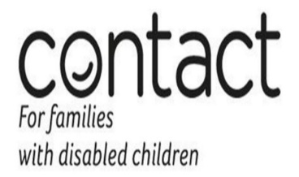  Contact website | Contact offer;  Workshops & events Listening Ear 1-1 emotional support telephone service.  Parent carer participation Support parent carer forums in England shaping local services. Information & advice Guidance for your family.
Leeds Local Offer  Directory (leedslocaloffer.org.uk) | The Leeds Local Offer provides information for children and young people with special educational needs and disabilities (SEND) and their parents or carers in a single place. It shows families what they can expect from a range of local agencies including education, health and social care.
NHS Every Mind Matters  Every Mind Matters - NHS (www.nhs.uk) | This website offers a range of mental health advice as well as an interactive quiz that’s designed to help you feel more in control of your emotional and mental wellbeing.
stem4 - supporting teenage mental health | A charity that promotes positive mental health in teenagers as well as encouraging them to build resilience and manage difficult emotions via online resources
Samaritans  Samaritans website | A charity that offers metal health support and information online for everyone. Their helpline is free and available to all ages. Call 116 123
Child Bereavement UK  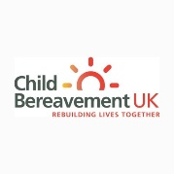  Child Bereavement UK | A site which has resources for young people who are grieving as well as providing information and advice to families/professionals on how to best support a young person who is bereaved. A helpline is also available on 0800028840
Combined Minds | This app contains psycho-education for parents, families and friends with practical advice on how to provide mental health support to children and young people
Clear Fear | An app to help children and teenagers manage anxiety through distraction and helpful activities.
Calm | A mindfulness app that includes various relaxing sounds to listen to as well as ‘sleep stories’ and some guided meditations
Headspace | A mindfulness app that has more of a ‘podcast feel’ to it with various talks, guided meditations and helpful videos available.
Cove | A relaxing musical app that helps people try to capture their mood and express it by making music within the program and capturing it in a journal format. Note: you do not need to know how to play and instrument to use this app.
National Autistic Society  National Autistic Society (autism.org.uk) | For parents of children with autism, young people and adults with autism  Call: 08088004104 (Monday to Thursday 10am to 4pm, Friday 9am to 3pm)
STARS TEAM  STARS Autism support - Support for Parents - Leeds (starsteam.org.uk)  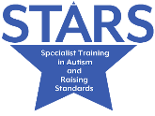 | Parent resources and support videos can be found on the parent section of our website. The STARS Team can be contacted on starsteam@leeds.gov.uk or 0113 3789792
Autism Education Trust  For Parents | Autism Education Trust | All children with autism are different. Our tools and resources – developed in collaboration with parents, practitioners and consultants with expertise in autism – are designed to explore and build on these differences to support every single child with autism to reach their full potential. Although our training materials and most of our resources are aimed at teaching professionals, you, as a parent, can help your child by recommending AET training to your child’s teachers and SENCO.
SNAPS  SNAPS Yorkshire – Special Needs and Parent Support  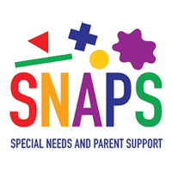 | SNAPS (Special Needs and Parent Support) is based in Leeds and provides support services for children with additional needs of all kinds, and their families.  SNAPS run swimming, rebound and football sessions which you need to register for. They also run term time Saturday stay and play sessions at Penny field & Broomfield school
Zig Zag  Home | ZigZag Leeds Autism Support Group (zigzagautismservices.co.uk)  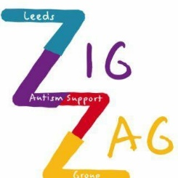 | Zig Zag run trampoline sessions at Gravity on Kirkstall Road on Thursdays and Sundays at 6pm  They also run soft play sessions – you can see all their events on their Facebook page here https://www.facebook.com/zigzag.leeds.autism.support/events/?ref=page_internal
Little Hiccups Parent and family support group  Little Hiccups – support – share – experience | Little Hiccups is a Leeds based support group that has been set up by parents who have children with additional needs and disabilities.  They have a varied support offer including; stay and play’s, days out, counselling, hire equipment and much more  Little Hiccups parent and family support group: Tel: 0783 123 0741 Email: info@littlehiccups.co.uk
ABC Parent support Group Autism Specific  Contact – Leeds ABC Group (wordpress.com) | ABC Parent support group (Autism specific):  We aim to provide help, support and advice about services, facilities education, care and welfare for parents and families of Autistic children.
Kidz ‘n’ Co  About Kidz ‘n’ Co | Kidz 'n' Co (wordpress.com) | Kidz 'n' Co runs sociable activities every Saturday during term time at Beeston Village Community Centre 11.00am -1.00pm  A friendly, safe environment for families with children and young adults with autism, SEN and additional needs aged 5 to 18 years old  https://www.facebook.com/Kidz-n-Co-496838057720938
Mencap Leeds  Leeds Mencap - Learning Disability Charity | Mencap Learning Disability | Leeds Mencap run Jimbo’s Community Nursery, a purpose-built nursery in east Leeds  Jimbo's Community Nursery - Learning Disability Charity - Leeds Mencap  They also run groups and activities for 4 – 18 year olds  Groups and activities - Learning Disability Charity - Leeds Mencap  They offer family support  Family support - Learning Disability Charity - Leeds Mencap  Tel: 0113 235 1331
Scope in Leeds  Parents and carers | Disability charity Scope UK | Scope offer 4 family services;  Sleep right, Parents connect, Activities for All and Navigate.
Carers Leeds  Carers Leeds – Supporting unpaid carers | Carers Leeds operates the single point of access for all carers in Leeds and offers information, advice and support.  Carers advice line – 0113 380 4300: Mon – Fri 9am – 5pm  Carers Leeds Facebook page is also good to follow, they have regular parent group meet ups just for parents https://www.facebook.com/Carers-Leeds-Parent-Carer-Page-109292184055851
Rising for the disabled  About Us - Riding for the Disabled Association (RDA) | RDA is an inclusive and diverse organisation. We welcome clients with physical and learning disabilities and autism, and there are no age restrictions. Through our network of member groups, RDA is at work in every corner of the UK, in our cities and remote rural areas, bringing the therapy, achievement and fun of horses to as many people as we can.  Riding for the disabled has several groups in Leeds: Tel: 01926 492915
Autism Angels  Autism Angels | Home | Parent support group which provides Equestrian therapy.  Our environment provides lots of opportunities for new adventures and discoveries. By coming back to nature, giving your mind a rest for a while and letting the environment do the work for you, you really do begin to feel like a different person. Come and breath in the fresh air, listen to the birds and relax with a cuppa as we talk about what you need.
Sendiass  Special Educational Needs and Dissabilities  Information Adivce Support Service  Leeds SENDIASS | SENDIASS support children and young people with special educational needs and disabilities (SEND) and their parents and carers to help with any concerns or questions.  They do this by providing a free, impartial and confidential service through their website and online resources. You can also contact them through the helpline: 0113 378 5020 (Monday to Friday, 10am to 3pm).  SENDIASS website news and events page is up to date with workshop dates and times. Service users can book via the advice line sendiass@leeds.gov.uk or through the get in touch page on our website https://forms.leeds.gov.uk/SENDIASSGetInTouch
Targeted short breaks  Short Breaks and Activities  www.leedslocaloffer.org.uk | The Fun Activities and Short Breaks Catalogue which gives details on what can be accessed can be found on the Leeds Local offer https://leedslocaloffer.org.uk/#!/model/page/service/33605.  Should you wish to speak to somebody or to find out what Fun Activities and Short Breaks would best suit your child, please contact short.breaks@leeds.gov.uk
Top Tips to say instead of stop crying | 